Project Design Phase-II
Data Flow Diagram & User Stories

Date | 31 January 2026
Team ID | LTVIP2026TMIDS38689
Project Name | Electric Motor Temperature Prediction using Machine Learning
Maximum Marks | 4 Marks

Data Flow Diagrams:
A Data Flow Diagram (DFD) is a traditional visual representation of the information flows within a system. A neat and clear DFD can depict the right amount of the system requirement graphically. It shows how data enters and leaves the system, what changes the information, and where data is stored.

Example: flow diagram(DFD)
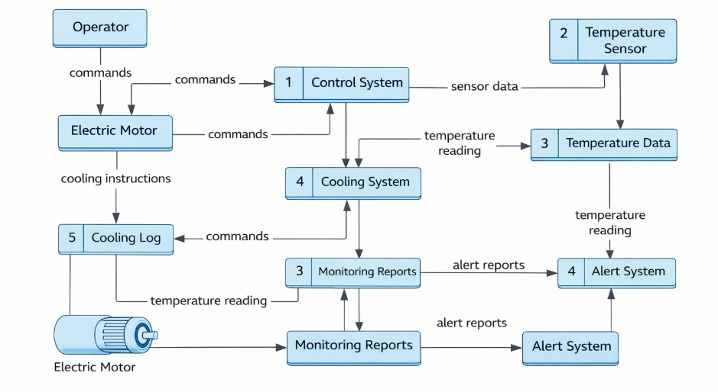

User Stories
Use the below template to list all the user stories for the product.
User Type | Functional Requirement (Epic) | User Story Number | User Story / Task | Acceptance Criteria | Priority | Release
Maintenance Engineer | Temperature Prediction | USN-1 | As a user, I want to input motor parameters (Ambient, Torque, Speed) to predict the motor temperature. | System displays the predicted temperature in Celsius (°C). | High | Sprint-1
Maintenance Engineer | Manual Testing | USN-2 | As a user, I can access the "Manual" page to test hypothetical motor load scenarios. | The predict_manual API returns a valid JSON prediction. | Medium | Sprint-1
Plant Operator | Sensor Monitoring | USN-3 | As an operator, I want a dedicated sensor input form for high-frequency data (u_d, i_d, u_q, i_q). | The sensor.html page renders the prediction result clearly. | High | Sprint-1
Data Scientist | Model Reliability | USN-4 | As a developer, I want the system to use a pre-trained Random Forest model for inference. | The app.py successfully loads sensor_model.pkl on startup. | High | Sprint-1
Industrial Supervisor | Data Integrity | USN-5 | As a supervisor, I want the system to handle invalid inputs (text in numeric fields) gracefully. | System displays an "Error..." message instead of crashing. | Medium | Sprint-2
Administrator | Cloud Deployment | USN-6 | As an admin, I want to deploy the application on a platform like IBM Watson for remote access. | The web app is accessible via a public URL. | Low | Sprint-2

